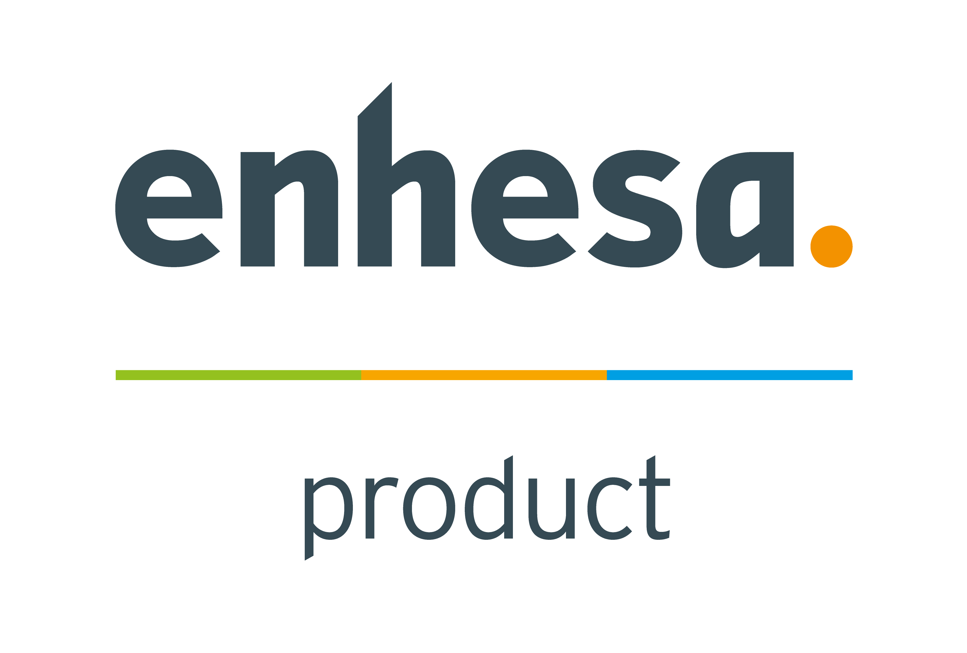
Event form

Logo requirements: Approximately 140 x 35 pixels in JPEG, PNG or GIF format, Static content only
Events page banner requirements: Must be 215 x 70 pixels in JPEG, PNG or GIF format, Static content only

Event name:

Event start date | Event end date

Organiser:

Location: Town/Country | Telephone for enquiries about event/registration

Email for event enquiries | Web (include http:// prefix)
 | http://

Description (up to 1,500 characters)

Please return to product.support@enhesa.com - Thank you

